**ARPU (Average Revenue Per User ) Analysis - Entertainment Sector**

Pooja Joshi & E.Code [E25007]

# Overview :

# This report presents an analysis using the ARIMA (AutoRegressive Integrated Moving Average) model for forecasting movie popularity trends. The ARIMA model was applied to movie popularity data, resampled monthly, to generate predictions for future popularity. The tasks completed today focused on time series modeling and forecasting, with the goal of understanding future demand trends for content licensing.

# Objective:

· To calculate ARPU based on total revenue and the number of users.

· To explore ARPU trends over time and by different content types.

· To identify segments for audience targeting strategies.

# Assigned Task(s) :

· Calculate ARPU for the dataset.

· Analyze ARPU by content type and time.

· Visualize ARPU trends and segment the analysis based on attendance counts.

# Task Details :

#### ****Task 1: ARPU Calculation and Analysis****

* **Status**: In Progress
* **Details**: The dataset (cleaned_trending_data.csv) was loaded, and ARPU was calculated using the formula: ARPU=Total RevenueNumber of UsersARPU = \frac{\text{Total Revenue}}{\text{Number of Users}}ARPU=Number of UsersTotal Revenue​ Additionally, ARPU was segmented based on user attendance counts to provide more detailed insights.

#### ****Task 2: ARPU Trend Analysis with ARIMA Forecasting****

* **Status**: Completed
* **Details**: The ARIMA model was applied to the time-series data resampled monthly, which aimed to forecast future ARPU trends and movie popularity. This approach helps in understanding future demand trends and content licensing strategies.

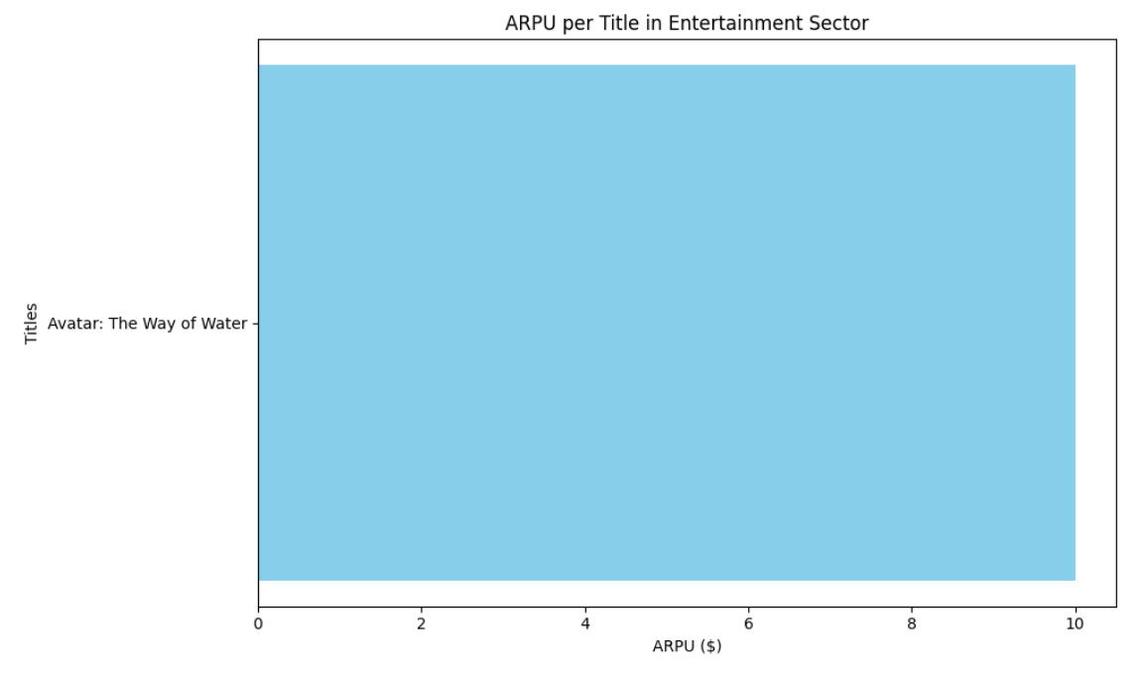

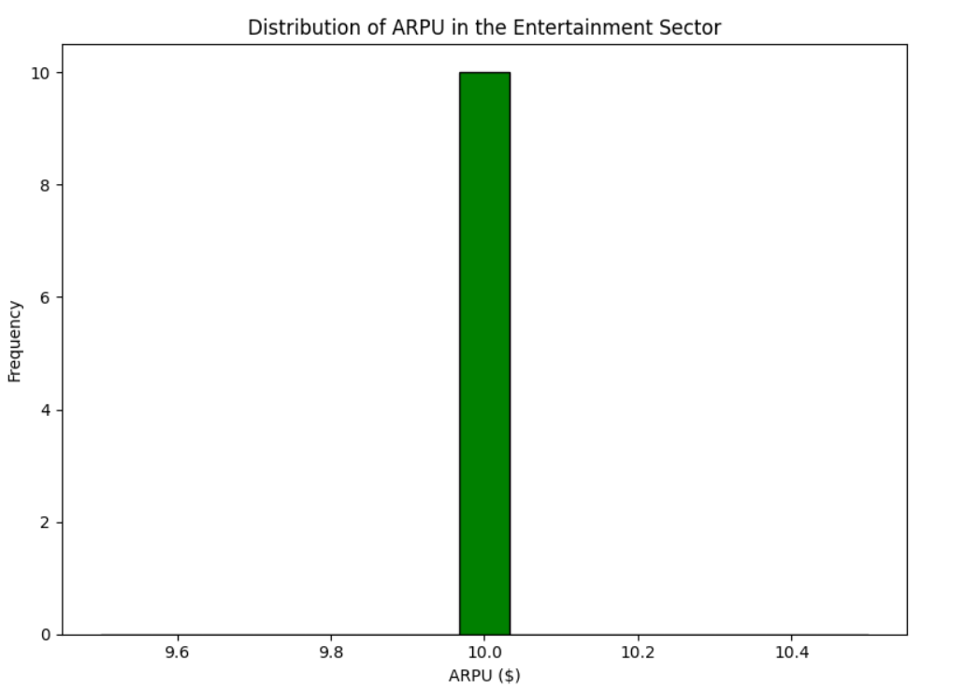

#### ****Task 3: Segmentation and ARPU Grouping****

* **Status**: Completed
* **Details**: ARPU was segmented based on attendance counts (Low, Medium, High, Very High), and the data was grouped to analyze ARPU trends for each segment.

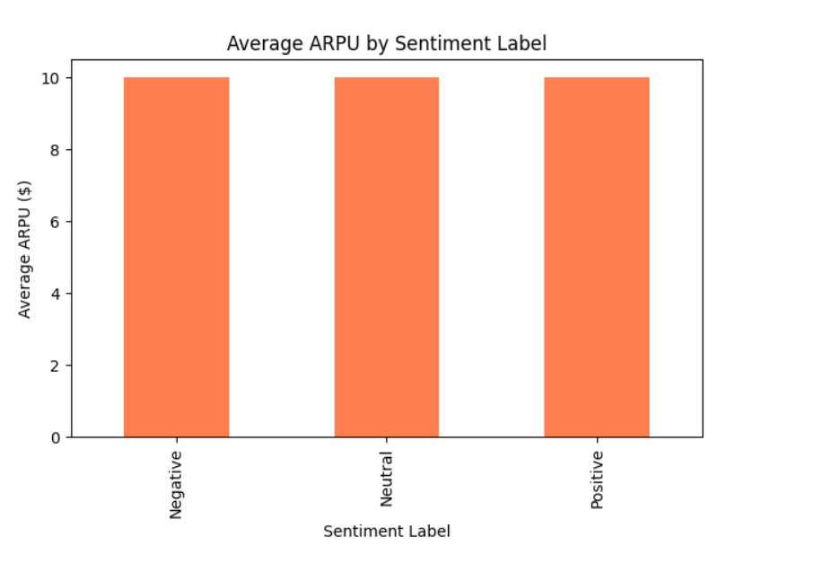

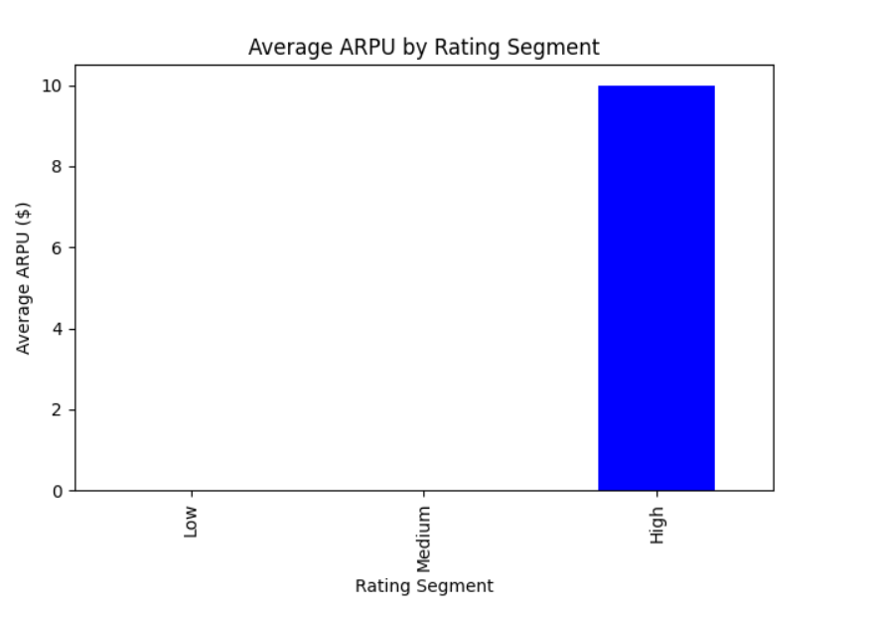

#### ****Task 4: Data Enhancement - Adding**** media_type ****and**** release_date ****Columns****

* **Status**: Completed
* **Details**: To proceed with ARPU analysis segmented by content type and release date, placeholder data for the media_type column and random release dates were generated. This allows for initial testing and analysis of ARPU trends based on both time and attendance segments. Future updates will incorporate actual data for more accurate insights.

# 

# 

# 

**Progress :**

· **Accomplishments:** Successfully calculated ARPU and explored potential visualizations. Encountered challenges related to missing columns, which have been noted for future data enhancements.

· **Metrics:** ARPU calculated for various entries in the dataset, providing a preliminary overview of user revenue.

# Challenges and Solutions :

· **Challenges Faced:**

* Missing columns such as media_type and release_date, which hindered grouping and time-based analysis.

· **Solutions Implemented:**

* Suggested generating a release_date column with random dates for testing and discussed future incorporation of actual content type data.

# Next Steps :

· **Upcoming Tasks:**

* Enhance the dataset by adding the media_type and actual release_date columns.
* Conduct time-based ARPU analysis once relevant data is available.

· **Goals:**

* Aim to provide deeper insights into ARPU trends and user engagement by segmenting data effectively.

# Conclusion :

# Summary: This report highlights the initial steps taken in analyzing ARPU within the Entertainment Sector, including the data preparation and preliminary calculations. Challenges regarding data limitations were identified, and solutions proposed for future analysis.

# **Acknowledgments**: Thank the audience for their time and attention.

# Instructions:

1. Use Google Docs. Single Column
2. TNR stands for Times New Roman: B - Bold
3. Use images as required with proper references
4. Use charts, tables as per your requirement.
5. Number of Pages: 2 to 8 for each task report.